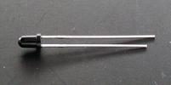
Features
˙Fast response time
˙High photo sensitivity
˙Small junction capacitance
˙Pb free

Descriptions
3004M1Dis a high speed and high sensitive PIN
photodiode in a standard 3Φplastic package.
The device is matched to infrared emitting diode.

Applications
․Automatic door sensor
․Copier
․Game machine

Device Selection Guide

LED Part No. | Chip | Lens Color
LED Part No. | Material | Black
F3接受管 | Silicon | Black

Package Dimensions
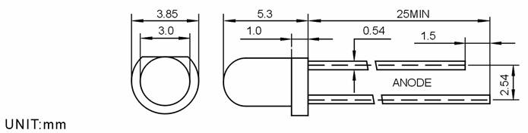

Notes:
1.All dimensions are in millimeters
2.Tolerances unless dimensions ±0.1mm

Absolute Maximum Rating (Ta=25℃)
Parameter | Symbol | Absolute Maximum Rating | Unit
Reverse Voltage | V_{R} | 30 | V
Power Dissipation | P_{D} | 100 | mW
Operating Temperature | Topr | -25～+85 | ℃
Storage Temperature | Tstg | -40～+85 | ℃
Soldering Heat (5s) | Tsol | 260 | ℃
Notes: *1:Soldering time≦5 seconds.

Electro-Optical Characteristics (Ta=25℃)
Parameter | Symbol | Min. | TYP. | Max. | Unit | Condition
Rang Of Spectral Bandwidth | λ0.5 | 400 | --- | 1100 | nm | ---
Wavelength Of Peak Sensitivity | λP | --- | 940 | --- | V | ---
Open-Circuit Voltage | VOC | --- | 0.39 | --- | V | Ee=5mW/cm2  λp=940nm
Short- Circuit Current | ISC | --- | 35 | --- | μA | Ee=1mW/cm2  λp=940nm
Reverse Light Current | IL | 25 | 35 | --- | μA | Ee=1mW/cm2  λp=940nm  VR=5V
Reverse Dark Current | ID | --- | 5 | 30 | nA | Ee=0mW/cm2  VR=10V
Reverse Breakdown Voltage | BVR | 32 | 170 | --- | V | Ee=0mW/cm2  IR=100μA
Total Capacitance | Ct | --- | 18 | --- | pF | Ee=0mW/cm2  VR=5V  f=1MHz
Rise/Fall Time | tr/tf | --- | 45/45 | --- | nS | VR=10V  RL=1000Ω
Note:
- Luminous intensity is measured with a light sensor and filter combination that approximates the CIE eye-response curve.
- θ_{1/2} is the off-axis angle at which the luminous intensity is half the axial luminous intensity.

